# How to start the application

Prerequisite:

Angular CLI version: v14.2.10

Node.js Version: v14.16.0

.Net Core: 6.0

Visual Studio 2022

Visual Studio Code

MSSQL : SQL server 2019

Step 1 : Restore the database

Option 1: Restore the Precision.bak in the database

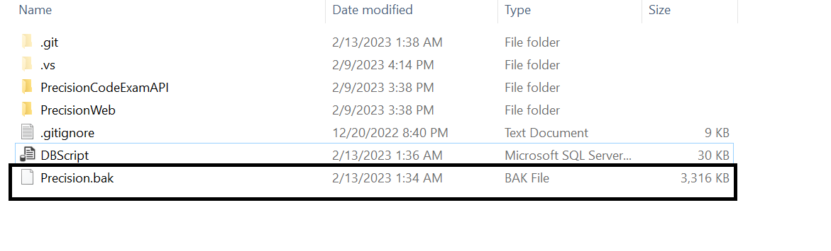

Option 2: Run the script in database

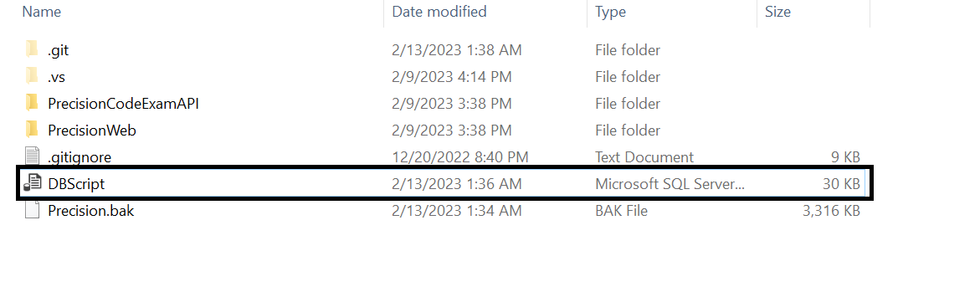

Step 2: Run the Application PrecisionCodeExamAPI/PrecisionCodeExamAPI.sln in Visual Studio 2022,

By default the Host number Is 5010,

* To test the api using swagger you can check the <http://localhost:5010/swagger/index.html>

Step 3: Open the PrecisionWeb\project-PrecisionWeb in Visual Studio Code

* To setup the API end point, You can check the AppSettings in src\assets\AppSettings.json
* 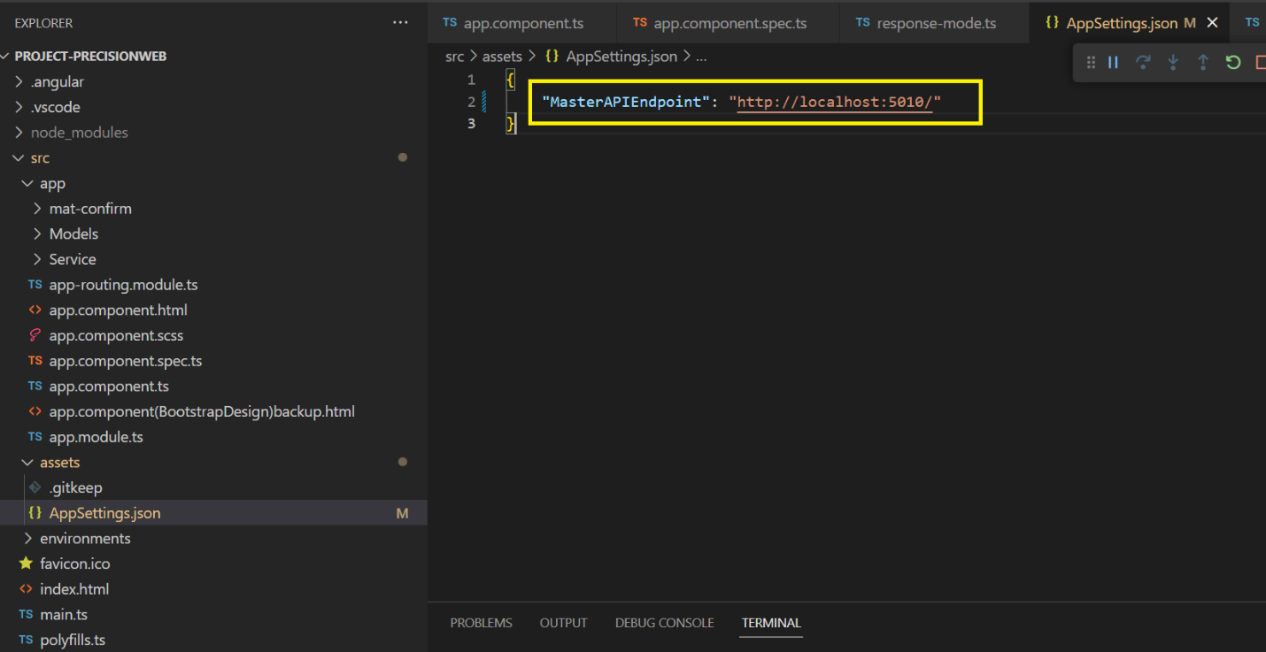

Step 4: Run the PrecisionWeb\project-PrecisionWeb in Visual Studio Code